ORDER GUIDE COMPARE
Beginner’s User Guide
Comparing model years of vehicle order guides in the jev-diff web app
Who this is for: anyone who has been comparing last year’s and this year’s order guide by printing both, laying them side by side and marking the differences with a highlighter — and the administrators who look after the app. No programming knowledge is needed.
What you will be able to do by the end: upload order guides once, produce a full list of what changed between any two model years in a few minutes, work through it from most important to least important, and hand colleagues a report or a marked-up Excel copy.
Version 2 · September 2026 · covers the web app

Contents

1. Welcome
Every model year each manufacturer publishes a new order guide: one section per area (Standard Equipment, Equipment Groups, Interior, Wheels and so on), one row per feature and one column per trim or equipment group. Someone has to work out what is different from last year, because those differences decide what can be ordered, on which trim, and under what conditions.
Until now that has been done on paper. jev-diff (we will just call it “the app”) does the same comparison in your web browser. You upload last year’s and this year’s order guides once, pick the two years, and the app gives you back:
- A list of every change, with the most important first, that you can search, filter and re-rank on screen.
- A downloadable report — a single web page you can email to anyone, which works without the app.
- A marked-up workbook — a copy of this year’s Excel file with every changed cell colored and a new “Change Log” tab at the front (for Excel order guides).

1.1 What is new in version 2
Version 1 of this guide described a command you typed into a terminal. The app replaces that with screens you click through, and adds several things the command could not do:
Before (command line) | Now (web app)
Copy the two Excel files into a project folder | Drag any number of files into the Document library; each is stored once
Type the model years on the command line | The app recognises the manufacturer, model and year and asks you to confirm
Compare exactly two years | Compare two years, or three or more as a timeline
GM Excel exports only | GM Excel exports and Ford PDF order guides
Rules built into the program | Rules are rulesets an administrator can edit per manufacturer and year range
Results in a file on your computer | Results are saved in the app, with links you can share with colleagues

Good to know
The command line still works for anyone who prefers it (see Appendix A). Everything in the rest of this guide uses the web app.

1.2 How the paper process maps to the app
If you know the paper process, you already know most of this app. Each paper step has a direct replacement:
On paper | In the app | Where to look
Collect both years’ order guides | Upload the files to the Document library | Section 4.2
Check you have the right vehicle and year | Confirm the app’s suggestion for each file | Section 4.3
Line the pages up side by side, row by row | Done automatically — rows are matched by option code and description | Pairing tab
Flip to the footnotes to decode every little number | Done automatically — footnote numbers are replaced by the footnote wording | Change cards
Highlight every cell that differs | Every changed cell is listed and colored | Changes tab, marked-up workbook
Decide which differences actually matter | Changes are sorted into material, review and cosmetic | Band buttons
Write up a list for the team | Send a link, the report or the marked-up workbook | Section 9
Circle the rows you could not match | Unmatched rows are collected in one place | Pairing tab

1.3 Why it is more reliable than comparing cells by eye
The small numbers in an availability cell (for example the 3 in “S3”) are footnote numbers, and manufacturers renumber the footnotes from year to year. On paper that means a cell can look different when nothing really changed, or look identical when an important condition was added. The app always compares the meaning of the footnote, not its number. Two real examples from the 2026 → 2027 GMC Yukon guides:
Option | What the cells looked like | What actually happened
5JL brakes | 5 cells looked different | Only one thing changed: the “requires 20″ or larger wheels” condition was dropped on three trims. Denali did not change at all.
SFE wheel locks | 1 cell went from ■3 to ■2 — looks like renumbering | A real change: Denali Ultimate gained a new “not available with (SPZ)” restriction. This affects orders.

Good to know
You no longer need to check footnote renumbering yourself. If a footnote number changed but its wording did not, the app deliberately does not report it.

2. Words you will see
The app uses a handful of terms. Most will be familiar from the order guide itself.
Term | Meaning
Order guide / document | The file published for one model and model year — an Excel (.xlsx) export for GM, a PDF for Ford. Once uploaded, the app calls it a document.
Catalog | The list of manufacturers (OEMs), their brands, models and model years that the app knows about — for example General Motors → GMC → Yukon → 2027.
Primary document | The document the app uses for a model year when you do not choose one. If you upload a corrected guide for the same year, you can make it primary.
Sheet (worksheet) | One section of the guide, such as Interior or Wheels. For PDF guides, each kind of page becomes a sheet (for example “Equipment Groups” or “GT – Standard Equipment”).
Trim / column | A column in a sheet — Elevation, AT4, Denali for GM; an equipment group such as 100A or 301A for Ford.
Code (RPO) | The option code, such as UKM, SPZ or 60G. Some rows have no code; they show a dash (—).
Availability | The symbol in a cell that says how a trim gets a feature (see 2.1).
Condition | The footnote or note wording attached to a cell, such as “Requires (SPY) Black lug nuts, LPO”.
Comparison | One run of the app between two model years of one model. Its results are saved and can be re-opened at any time.
Timeline | Three or more model years compared as a chain of pairs (2025→2026, 2026→2027, …).
Change | One item in the results: one row that differs between the two years, possibly on several trims.
Band | How important the app thinks a change is: material, review or cosmetic.
Lens | The point of view used to decide the band. Ordering accuracy (the default) cares about what dealers can order; content ops cares about what published content must change.
Judgments | The optional ranking step. The app asks an AI service (TypeSafe Jev) a few precise questions about each change; the answers become the bands.
Ruleset | The instructions that tell the app how to read one manufacturer’s guides: which sheets exist, what the footnote phrases mean, the questions to ask, and so on. Looked after by administrators.
Job | Work the app does in the background: reading a document, running a comparison, testing a ruleset or building an export.
Paired | A row from last year that the app matched to a row this year.

2.1 Availability symbols
The app shows each manufacturer’s symbols exactly as they appear in the guide.

GM (Excel order guides)
Symbol | Meaning
S | Standard — comes with the trim.
A | Available — can be ordered as an option.
A/D | Available, dealer-installed.
D | Dealer-installed.
■ | Included in an equipment group (package).
□ | Included in an equipment group, but can be upgraded.
* | Multi-model entry.
-- (or blank) | Not available on this trim.

Ford (PDF order guides)
Symbol | Meaning
S | Standard equipment.
O | Optional — ordered separately.
I | Included in the equipment group.
P | Included with the Performance Package.
◼ | Available (paint, seat-belt and stripe charts).
-- (or blank) | Not available.
O/-- , S/O, O/I … | Two or three symbols joined by a slash. The parts differ by body style or configuration — for example optional on the Fastback, not available on the Convertible. The app treats a change between, say, O and O/-- as a real change.

2.2 The kinds of change
Each change card has a small label telling you what sort of change it is. You can filter by these on the Changes tab.
Kind | What it means
availability | The symbol changed for at least one trim (for example S → --).
constraint | The symbol is the same, but the conditions (footnote or note wording) changed.
row added | A row exists this year that did not exist last year.
row removed | A row from last year is gone this year.
membership | A row moved on to, or off of, a particular sheet.
description | Only the description text of the row changed.
identity | An option’s code changed status, the trim line-up changed, or a whole sheet was added or removed (for example the 2026 Mustang guide gained a Seat Belt Colors page).

3. Finding your way around
Open the app in your web browser using the address your administrator gave you (for example http://127.0.0.1:8000). Every page has the same layout: a menu down the left side, and the page you chose on the right.
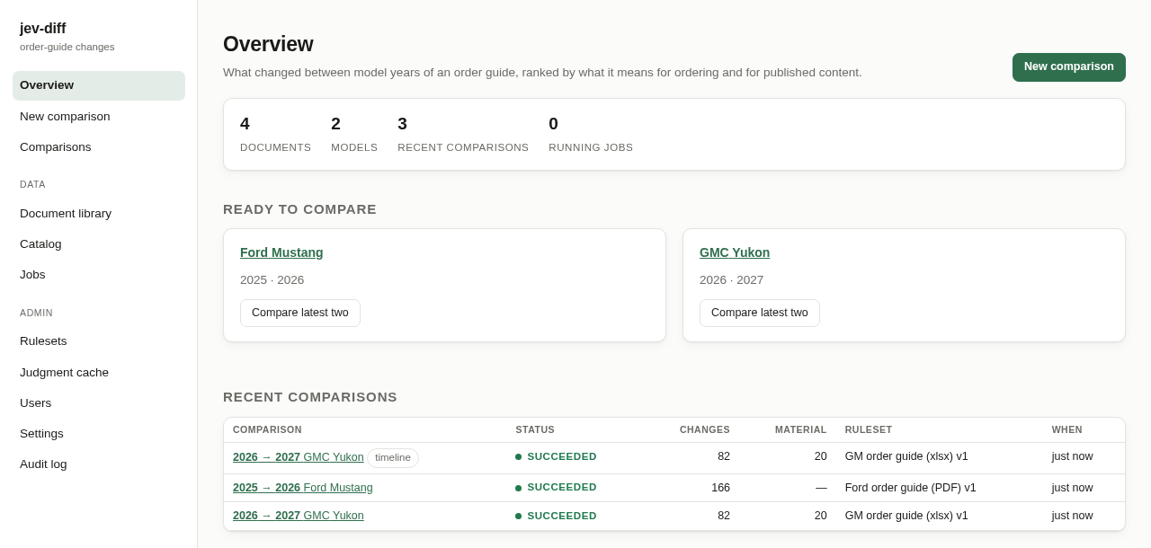
Figure 1. The Overview page, with the menu on the left.
Menu item | What it is for | Details
Overview | The home page: what is running, what is waiting for you, and your latest comparisons. | 5.1
New comparison | Pick a model and two or more years, and start a comparison. | 4.5, 5.4
Comparisons | Every comparison ever run, newest first. Click one to open its results. | 5.5, 6
Document library | Upload order guides, confirm what each one is, and check they were read correctly. The number next to it is how many uploads are waiting for you to confirm. | 4.2–4.4, 5.2
Catalog | Manufacturers, brands, models and model years, and what the app holds for each. | 5.3
Jobs | Everything the app is doing or has done in the background, with progress bars. The number is how many jobs are running now. | 5.7
Rulesets | (Administrators) How the app reads each manufacturer’s guides. | 7.1–7.3
Judgment cache | (Administrators) The saved answers that make re-running a comparison free. | 7.4
Users | (Administrators) Who can use the app, and as what. | 7.5
Settings | (Administrators) The ranking service’s key and options. | 7.6
Audit log | (Administrators) A record of who changed what. | 7.7

At the bottom of the menu you can see who you are signed in as and your role, and a theme button that switches between light and dark colors. The app remembers your choice.
Good to know
There are two roles. Analysts upload documents and run comparisons. Administrators can also manage rulesets, users and settings; the Admin section of the menu only appears for them.

4. Your first comparison, step by step
This section takes you from two order-guide files to a ranked list of changes. Allow about ten minutes the first time; after that a comparison takes one or two.

4.1 Before you start
You need:
- The two order guides for the same vehicle, one for each model year, exactly as downloaded from the manufacturer — Excel exports for GM, PDFs for Ford. Do not edit them first.
- The app’s address, from your administrator.
- For ranked results, the ranking service set up by an administrator (Section 7.6). Without it you still get every change, just not sorted into bands.
Good to know
Do not tidy up, re-save or re-sort the files before uploading them. The app recognises the layout the manufacturer produces. If a file has been changed so much that it no longer recognises the layout, it will say so rather than risk quietly missing changes (see Section 10).

4.2 Step 1 — Upload the order guides
Click Document library in the menu. At the top is a large box that reads Drop order guides here.
- Drag both files from File Explorer onto the box — or click the box and pick them. You can upload many files at once, for different vehicles and years.
- Wait a few seconds while the app stores each file and works out what it is.
- Each file appears under Needs confirmation.
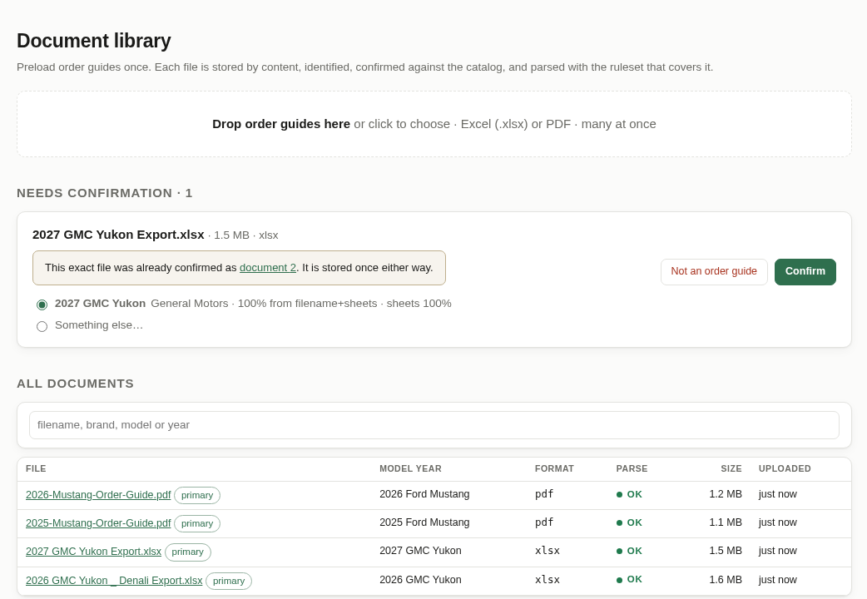
Figure 2. The Document library, with one upload waiting to be confirmed and four documents already on file.
Tip
Each file is stored once, however many times it is uploaded. If you upload a file the app already has, it tells you (“This exact file was already confirmed as document 2”) so you can simply confirm or dismiss it.

4.3 Step 2 — Confirm what each file is
For each upload, the app suggests the manufacturer, brand, model and model year — for example 2027 GMC Yukon — and how confident it is. The suggestion comes from the file name and from the sections the file contains.
- If the suggestion is right, click Confirm. If the model year is new to the app, the button reads Confirm & add to catalog and the year is added for you.
- If it is wrong, choose Something else… and type the OEM, brand, model and year. The boxes suggest names the app already knows.
- If the file is not an order guide at all, click Not an order guide.
Good to know
Nothing is compared until you confirm. This is deliberate: a file assigned to the wrong year would turn a comparison inside out, so a person always checks.

As soon as you confirm, the app reads (“parses”) the document in the background. The first document you confirm for a year becomes that year’s primary document.

4.4 Step 3 — Check the document was read correctly
Click a document’s name in the All documents list to open its page. The first box tells you at a glance whether the file was read cleanly:
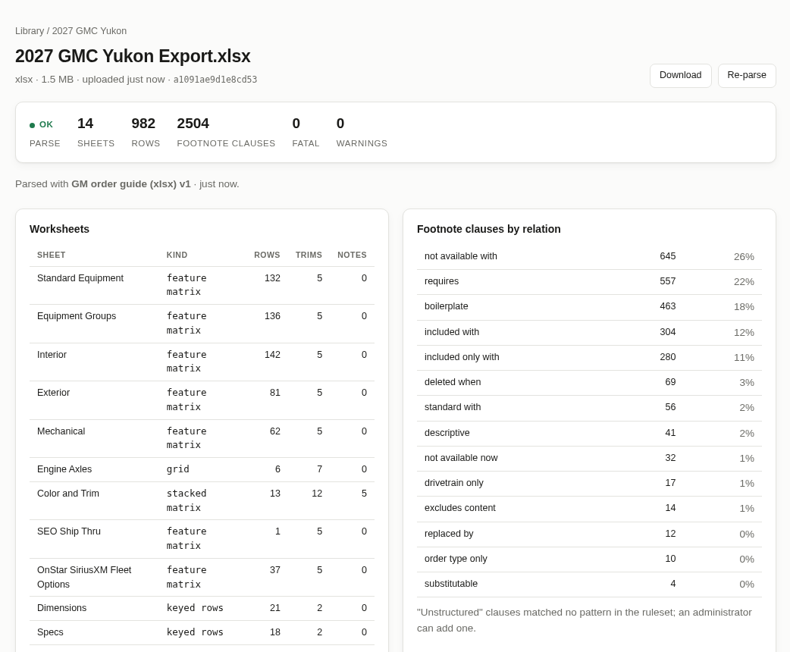
Figure 3. A document’s page: 14 sheets and 982 rows read, no problems.
Parse status | What it means
OK | Every sheet was recognised and read. Nothing to do.
Warnings | Read, with small issues listed at the bottom of the page. Comparisons still run.
Fatal | Something could not be read safely (for example an unrecognised sheet). Comparisons using this document are blocked until it is fixed — see Section 10.
Failed | The file could not be read at all. Check it is the original download.

The two tables show each sheet the app found (with its rows and trims), and how the footnote wording was classified — requires, not available with, and so on. “Unstructured” means a footnote phrase the app has no rule for yet; an administrator can add one.
The buttons at the top let you Download the original file, Re-parse it (for example after an administrator improves the rules) and Make primary for its year.

4.5 Step 4 — Start the comparison
Click New comparison in the menu, or the Compare latest two button on the Overview page. The page walks you through five numbered boxes:
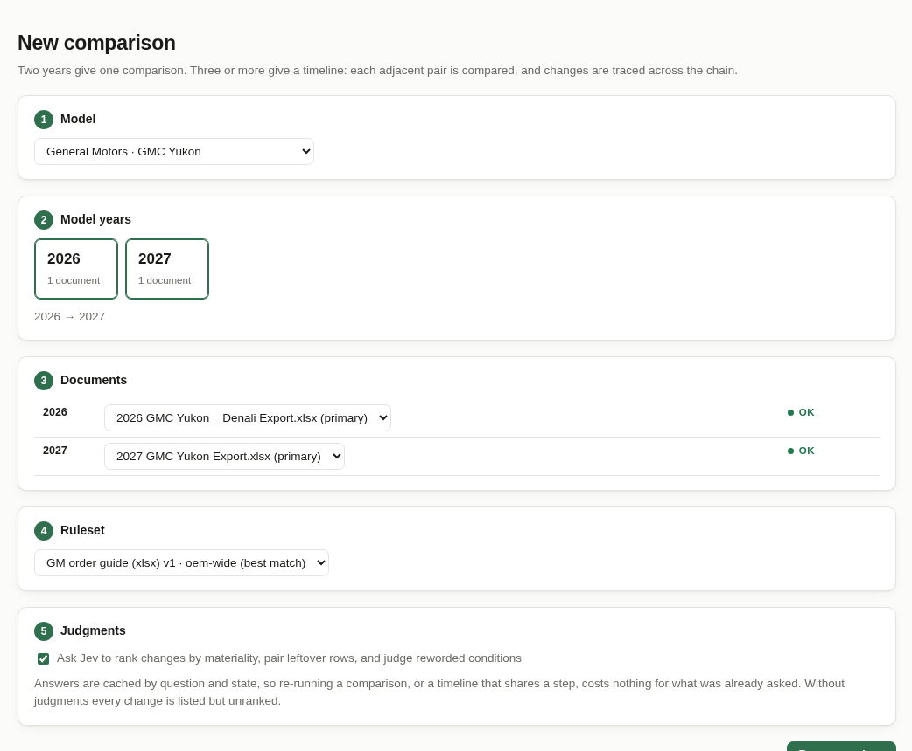
Figure 4. Starting a comparison of the 2026 and 2027 GMC Yukon.
- Model — pick the vehicle, for example General Motors · GMC Yukon.
- Model years — click the years to compare. Two years give one comparison; three or more give a timeline (Section 5.6). Years with no confirmed document are greyed out.
- Documents — the app picks each year’s primary document; change it here if you have more than one. The status next to each shows whether it was read cleanly.
- Ruleset — the app picks the best-matching ruleset for these years. Leave this alone unless an administrator has asked you to try a different one.
- Judgments — leave Ask Jev to rank changes ticked to get material / review / cosmetic bands. Untick it for a quick, unranked list.
Then click Run comparison (or Run timeline).
Good to know
Ranking costs a small amount the first time a pair of guides is compared — well under one US cent for the GMC Yukon — and nothing afterwards. Answers are saved by the exact question and the exact change, so re-running a comparison, or a timeline that shares a step, re-uses them.

4.6 Step 5 — Watch it run
The app opens the comparison’s page straight away and shows a progress bar while it reads both documents, matches the rows, finds the changes and ranks them. A comparison of two Excel guides takes well under a minute when the answers are already saved; the first ranked run of a new pair takes a minute or two; PDF guides take a little longer to read.
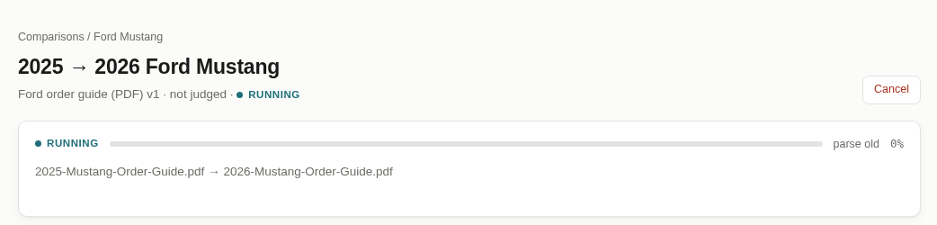
Figure 5. A comparison in progress.
- You do not need to wait on this page. Leave it and come back — the work carries on in the background, and the Jobs page and the menu show it running.
- Cancel stops the run. Any ranking answers already received are kept, so running it again later picks up where it stopped.
- If a run fails, the page shows the reason in red. The most common causes are listed in Section 10.

4.7 Step 6 — Read the results
When the run finishes, the page switches to the results, opening on the changes tab. Section 6 explains everything on it. In short: read the material changes first, then review, then check the pairing tab for rows the app could not match on its own.

5. The areas of the app
This section describes every page reached from the upper part of the menu. The comparison results pages have a section of their own (Section 6), and the administrator pages are in Section 7.

5.1 Overview
The page the app opens on. From top to bottom:
- Summary numbers — how many documents, models and recent comparisons the app holds, and how many jobs are running.
- A reminder when uploaded documents are waiting for you to confirm them, with a link to the library.
- Running — anything the app is working on right now, with progress bars.
- Ready to compare — every model with documents for at least two years, with a Compare latest two button that fills in the New comparison page for you.
- Recent comparisons — the latest runs with their status, number of changes and number of material changes. Click one to open it.

5.2 Document library
Where order guides come into the app, and where you check them (Sections 4.2 to 4.4 walk through it). The page has three parts:
- The upload box — drop Excel (.xlsx) or PDF order guides here, many at once.
- Needs confirmation — uploads waiting for you to say which vehicle and year they are.
- All documents — everything on file, with its model year, format, whether it was read cleanly, size and upload date. The search box filters by file name, brand, model or year. The primary tag marks each year’s default document.
Clicking a document opens its page (Figure 3), which shows how it was read, which ruleset was used, and any warnings.

5.3 Catalog and model pages
The Catalog lists each manufacturer, its brands and their models. Under each model the model years are shown as small chips; a green chip means the app holds a document for that year.
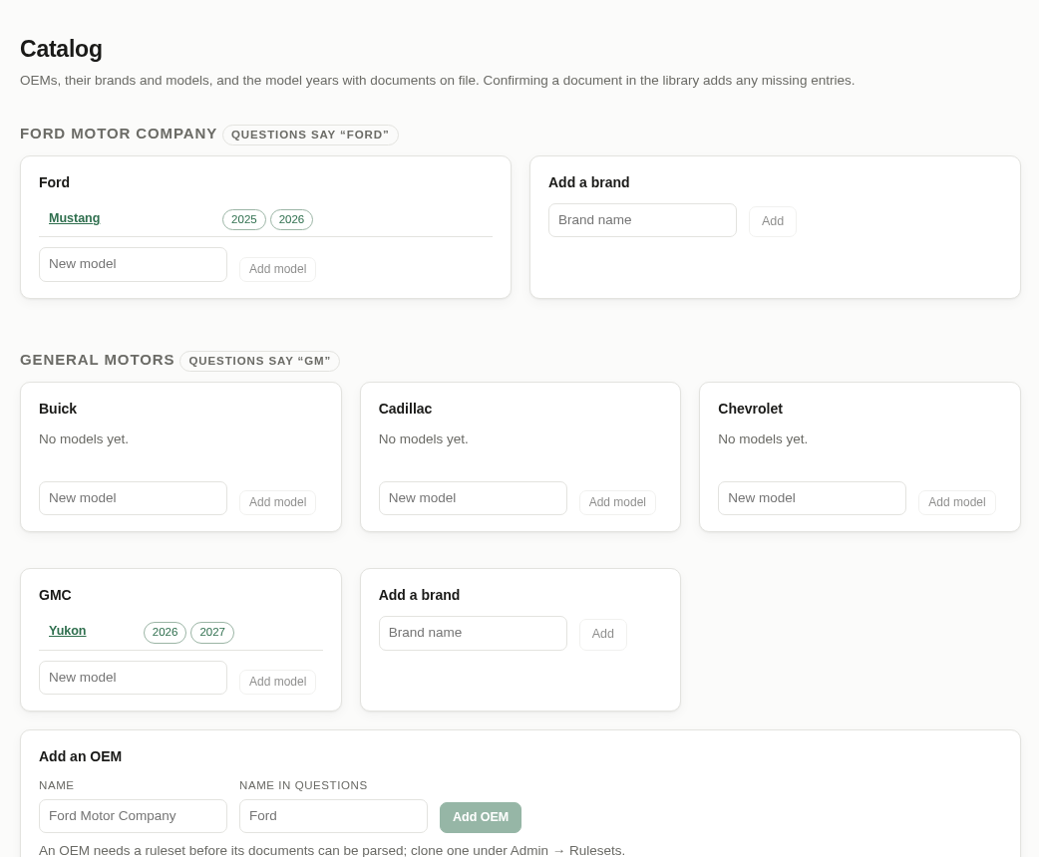
Figure 6. The Catalog.
You can add a brand, model or model year here — useful before a new guide arrives. (Adding a whole new manufacturer is for administrators, because it also needs a ruleset; see Section 7.1.) Confirming an upload for a year the app does not know yet adds it automatically, so you rarely need to do this by hand.
Click a model’s name to open its model page:
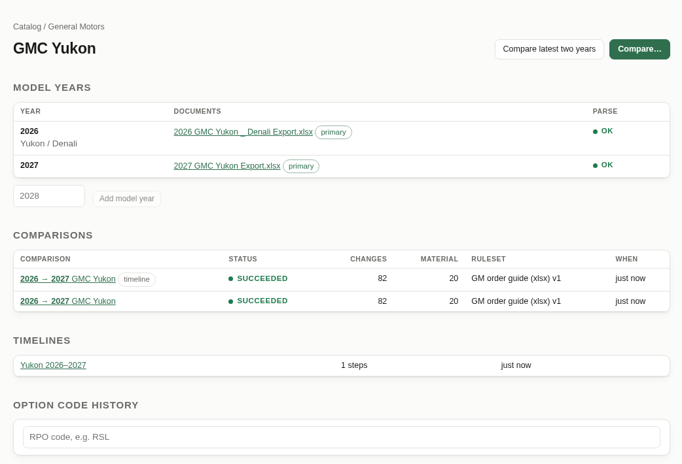
Figure 7. The model page for the GMC Yukon.
- Model years — each year, its documents and whether they were read cleanly. Type a year and click Add model year to add one.
- Compare latest two years and Compare… — shortcuts to the New comparison page with this model filled in.
- Comparisons and Timelines — every run for this model.
- Option code history — type an option code (for example RSL) to see every change to it across all of this model’s comparisons, with links to each change card. Useful for questions like “when did this package last change?”.

5.4 New comparison
Described step by step in Section 4.5. Two more things to know:
- The page remembers nothing between visits; the buttons elsewhere in the app (Compare latest two, Compare…) fill it in for you.
- If no ruleset covers the chosen manufacturer and years, box 4 says so in red and the comparison cannot start. Ask an administrator (Section 7.1).

5.5 Comparisons
Every comparison ever run, newest first, with its status, number of changes, number of material changes (using the ordering lens) and the ruleset it used. Steps of a timeline carry a timeline tag. Click a row to open it.
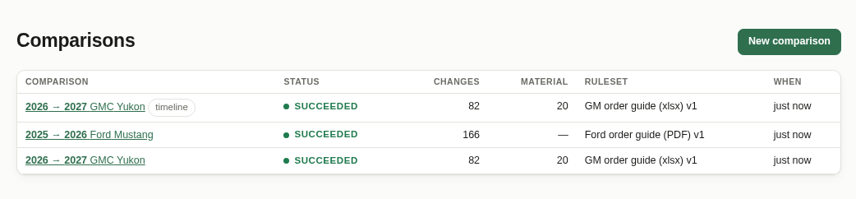
Figure 8. The Comparisons list.

5.6 Timelines
Choose three or more years on the New comparison page and the app runs a timeline: one comparison for each pair of neighbouring years, in order. The timeline page shows one row per step with its status and how many changes of each kind it found. Click a step to open it as a normal comparison.
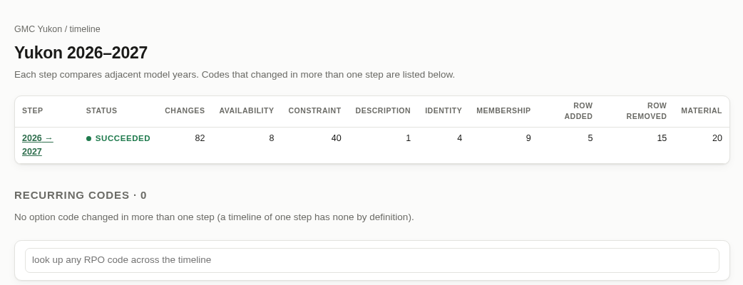
Figure 9. A timeline page (this one has a single step).
- Recurring codes lists option codes that changed in more than one step — often a sign of a feature being reworked over several years. Click a code to see its history.
- The search box at the bottom looks up any option code across the whole timeline; press Enter.
Good to know
Each step is an ordinary comparison, so its saved answers are shared: if you already compared 2026 → 2027, a 2025 → 2027 timeline re-uses that step’s ranking at no cost.

5.7 Jobs
Everything the app does in the background — reading documents, running comparisons, testing rulesets, building exports — is a job. The Jobs page lists them with a progress bar, what they belong to (with a link), and when they started. Running jobs have a cancel button.
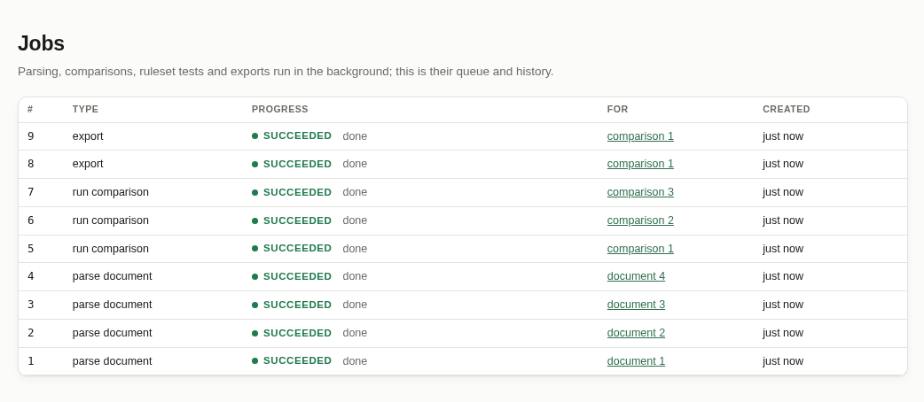
Figure 10. The Jobs page.
You rarely need this page: each job’s progress is also shown where you started it. It is most useful for checking whether the app is busy, or finding out why something failed.

6. Reading a comparison
A comparison’s page has a heading, a row of tabs and, under the tabs, the content of the tab you picked.
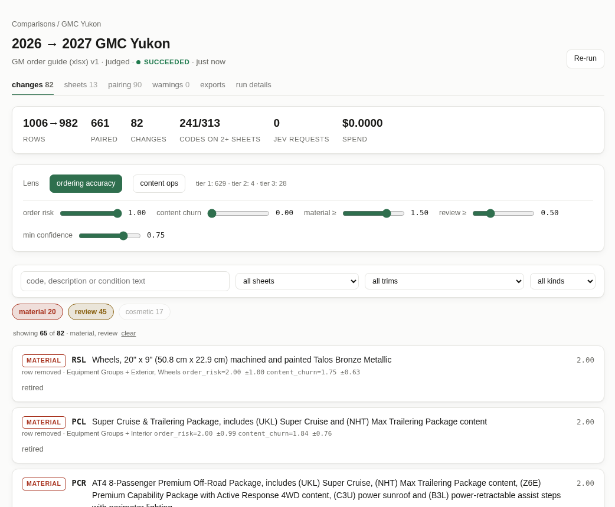
Figure 11. A finished comparison, on the changes tab.

6.1 The heading
The heading names the comparison (for example 2026 → 2027 GMC Yukon). The line under it shows the ruleset used, whether the changes were ranked (“judged”), the status and when it finished. The small links above the title take you back to the comparison list and the model page.
Re-run runs the comparison again — for example after a document was replaced or a ruleset improved. Saved answers are re-used, so re-running is usually quick and free.
Tab | Use it to…
changes | Work through the list of changes, most important first. This is where you will spend most of your time.
sheets | See a whole sheet laid out like the paper page, with changed rows marked.
pairing | Check the rows the app could not simply match up between the two years.
warnings | See any problems the app met while reading the two documents.
exports | Download the report file or the marked-up workbook.
run details | See which documents, ruleset and settings were used, and what the ranking cost.

The number next to a tab is a count (82 changes, 13 sheets, 90 pairing items).

6.2 The changes tab
From top to bottom the changes tab has five parts.

Summary numbers
Rows shows how many rows each year has (1006 → 982). Paired is how many were matched. Changes is the number of change cards. Jev requests and spend show how many ranking questions were actually sent and their approximate cost — 0 when every answer was already saved.

Lens and sliders
These control how changes are sorted into bands. You do not need to touch them. The default, ordering accuracy, puts first anything that changes what a dealer can order. For the opposite emphasis — what published content must change — click content ops.
The sliders set how much each score counts and where the band boundaries are. Moving one re-sorts the list instantly; nothing is re-run and nothing is saved for anyone else. To go back to the defaults, click the lens button again.

Search box and filters
Type in the search box to find changes by option code (UKM), description (“wheel locks”) or condition text (“22-inch”). The three drop-downs narrow the list to one sheet, one trim or one kind of change.

Band buttons
The colored buttons under the search bar show how many changes are in each band, and switch each band on or off:
Band | What it means and what to do
material | Very likely to affect orders. Read every one.
review | Might matter. Read each one and decide.
cosmetic | Very unlikely to matter (wording tidied up, footnote reorganised). Hidden when the page opens — click the button to show them.
unjudged | Appears when the comparison ran without ranking. Treat these as “review”.

Just above the first card, a line such as showing 65 of 82 · material, review tells you exactly which filters are on. Click clear to reset them.

6.3 Reading a change card
Each change is a card. Here is a real one:
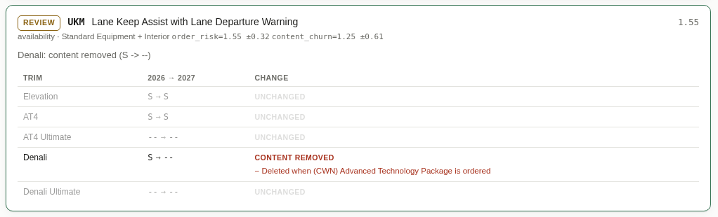
Figure 12. A change card: Lane Keep Assist removed from Denali.
Reading it from top left:
- Band (REVIEW) — how important the app thinks this change is.
- Code and description (UKM, Lane Keep Assist with Lane Departure Warning) — the row in the order guide.
- Score (1.55, on the right) — the number the band comes from. Higher means more important. The list is sorted by this number.
- Kind and sheet (availability · Standard Equipment + Interior) — the type of change, and where it is. “+ Interior” means the same row also changed the same way on the Interior sheet, so you only need to read it once.
- Summary sentence (Denali: content removed (S -> --)) — the whole change in one line.
- Trim table — one line per trim showing last year → this year, and what changed. Unchanged trims are grey so the changed ones stand out.
The small grey text after the sheet name (order_risk=1.55 ±0.32 …) shows the scores behind the band; you can ignore it. In the trim table, lines starting with + (green) are conditions added this year and lines starting with − (red) are conditions dropped.
Tip
Click anywhere on a card and the browser’s address changes to a link to that exact card. Copy it from the address bar to point a colleague straight at it (Section 9).

A card for a removed row just says retired: the option is gone this year. A card that says needs review means the app could not be sure whether a row is brand new or last year’s row reworded — check the pairing tab.

6.4 The sheets tab
The sheets tab looks most like the paper order guide. Pick a sheet from the list on the left; the number next to each name is how many changed rows it has.
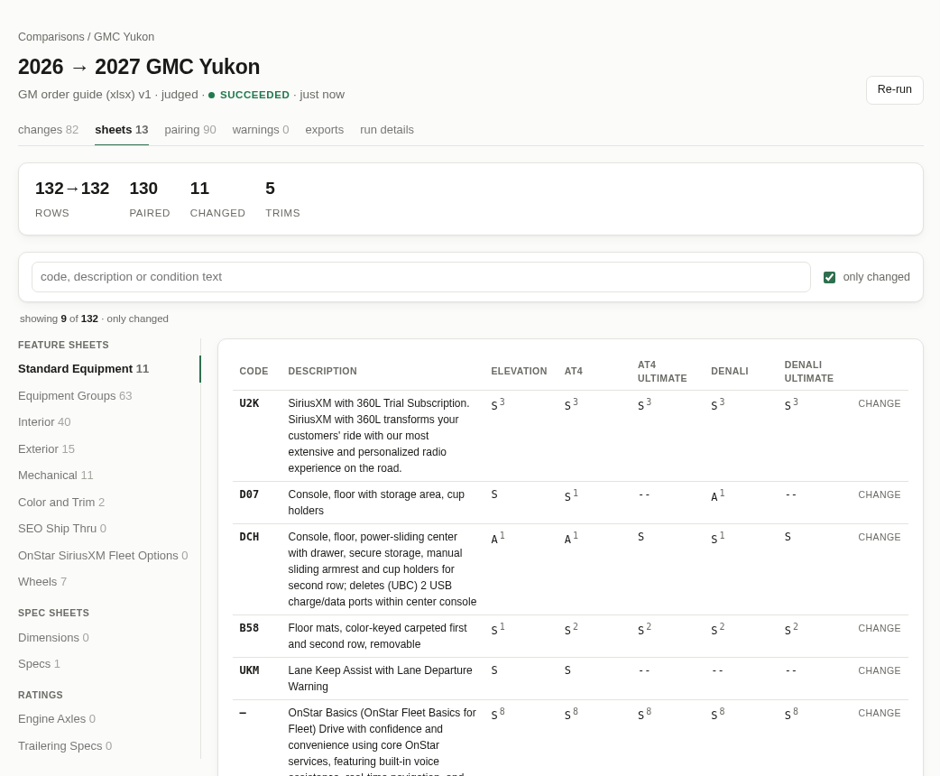
Figure 13. The Standard Equipment sheet with “only changed” ticked.
- Tick only changed to hide every row that did not change — the quickest way to review one sheet at a time, the way you used to go page by page.
- The small raised number after a symbol (S³) is the number of conditions on that cell; hover over the cell to read them.
- Click CHANGE at the end of a row to jump to that row’s change card.
- The search box works here too, and searches codes, descriptions and conditions.
- The trim lineup at the top of each sheet shows the columns in both years side by side, so an added, removed or renamed trim is easy to spot.

6.5 The pairing tab
Before it can compare anything, the app has to line up each row from last year with the same row this year — the job you did by running a ruler down both printouts. It matches almost every row on its own. The pairing tab lists the rows it could not simply match, grouped by reason:
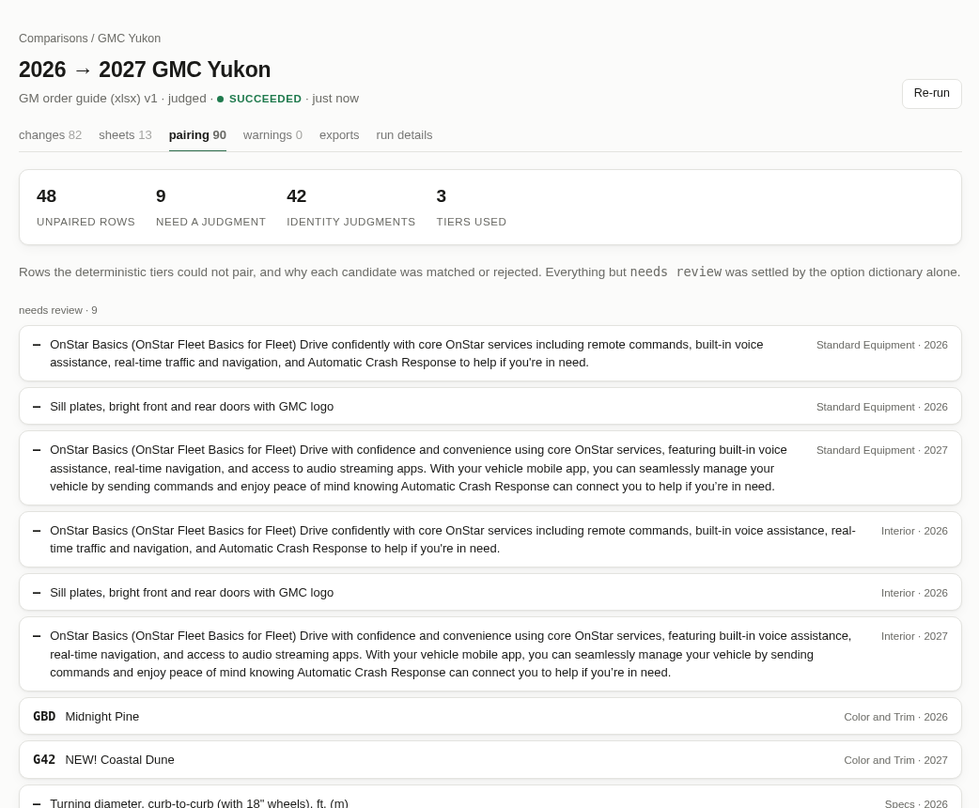
Figure 14. The pairing tab. “needs review” is the group to check.
Group | What it means
needs review | The app could not decide on its own. Look at these. They are usually the same feature with reworded text.
retired | The option exists last year only.
introduced | The option exists this year only.
moved off / onto sheet | The option is still offered but is listed on a different sheet this year.
listing removed / added | The option dropped off, or was added to, one sheet’s listing.

The Identity judgments table at the bottom shows how the app decided on uncertain matches when ranking was on: pair (same row), unlink (different rows) or review (not sure). You normally do not need it.

6.6 The warnings tab
Lists anything the app noticed while reading the two documents — for example a cell it did not recognise. Warnings do not stop a comparison; they tell you where to double-check against the original guide. An empty tab (“Both documents parsed without warnings”) is the usual case.

6.7 The exports tab
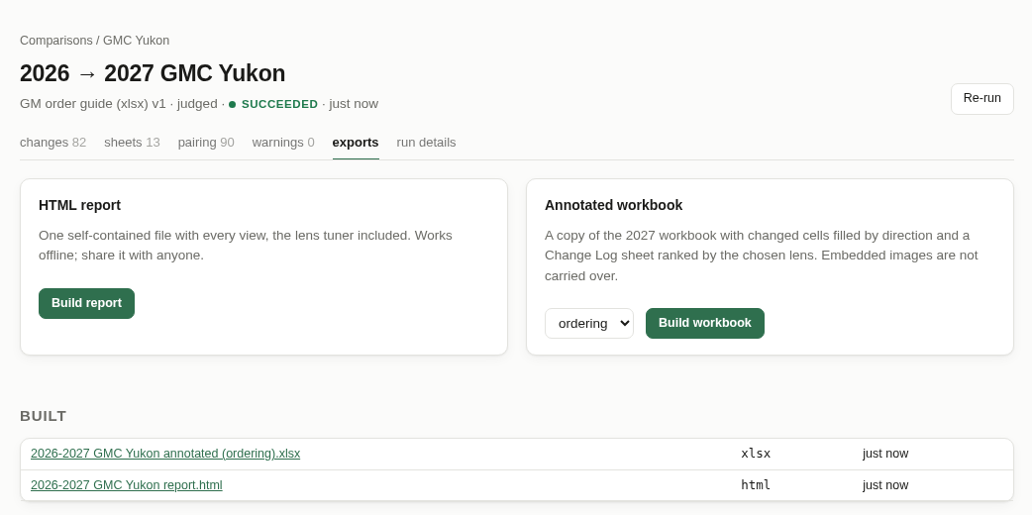
Figure 15. The exports tab, with one report and one workbook already built.

HTML report
Click Build report to make a single web-page file containing every view — changes, sheets, pairing and the lens sliders. It opens in any browser by double-clicking, works without an internet connection and without the app, and does not send your data anywhere. This is the easiest thing to email to someone who does not use the app.

Annotated workbook (Excel order guides only)
Choose a lens and click Build workbook to get a copy of this year’s Excel file with every changed cell colored and a Change Log tab at the front. Built files appear under Built; click a name to download it. Builds are kept, so colleagues can download them later.
The Change Log lists every change, one line per changed cell:
Column | What it holds
Band | material, review or cosmetic, for the lens you chose.
Score | The importance score. Sort largest to smallest to put the most important changes first.
Kind | The kind of change (availability, constraint, …).
Code | The option code.
Sheet / Cell | Where the changed cell is — for example Standard Equipment, cell G14.
Trim | Which trim column.
Change | Old symbol → new symbol, and the type of change, for example “S -> -- (content removed)”.
Description | The row’s description.
Detail | Conditions added (+), dropped (−) or reworded (~).

In the ordinary sheets, every changed cell is filled with a color showing which way it changed. A legend is repeated at the bottom of the Change Log.
Label | Meaning
content added | Was not available, now is.
content removed | Was available, now is not.
upgraded | Easier to get (for example optional → standard).
decontented | Harder to get (for example standard → optional).
package shift | Moved between ordered separately and part of a package.
fulfillment shift | Same availability, obtained differently (for example A → A/D).
constraint only | Same symbol, but its conditions changed.
incomparable | The trim does not exist in the other year.

Good to know
The color tells you the direction of a change, not how important it is. For importance, use the Band column.
Pictures from the original workbook (such as wheel photographs) are not included in the marked-up copy. Keep the original for those — you can always download it from the document’s page.
The workbook needs an Excel order guide for this year. For PDF guides, use the HTML report.

6.8 The run details tab
Shows exactly what the comparison used — the two documents (with links), the ruleset and its version, whether ranking was on — and what the ranking cost: requests sent, tokens used, and how many answers came from the saved cache. Useful when two people get different results and want to know why.
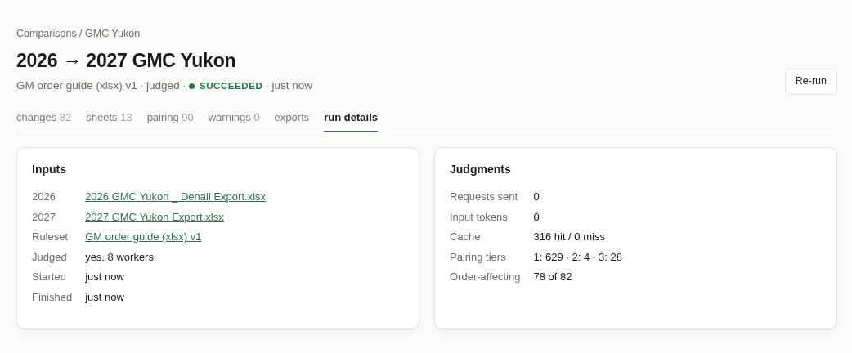
Figure 16. The run details tab. 316 answers came from the cache, so nothing was paid for.

6.9 What is different about Ford PDF guides
Ford publishes its order guides as PDFs laid out per series (EcoBoost, EcoBoost Premium, GT, GT Premium, Dark Horse). The app reads them into the same kind of sheets as GM’s, with a few differences worth knowing:
Sheet | How it is laid out
Equipment Groups | Every series’ equipment-group pages combined into one sheet. Each column is an equipment group (100A, 101A, 200A …) and each row is an option code. An option not listed for a series is shown as not available there, so an option newly offered on another series shows up as a change.
<series> – Standard Equipment | One sheet per series. The higher series list only what they add to the one below, so they are kept apart rather than merged.
Color & Trim, Seat Belt Colors, Stripe Offerings | One row per paint or seat-belt code, one column per equipment group and interior trim code (for example 100A DW) or stripe code (85D).
Rear Axle Ratios | The axle-ratio table from the Functional Equipment pages.

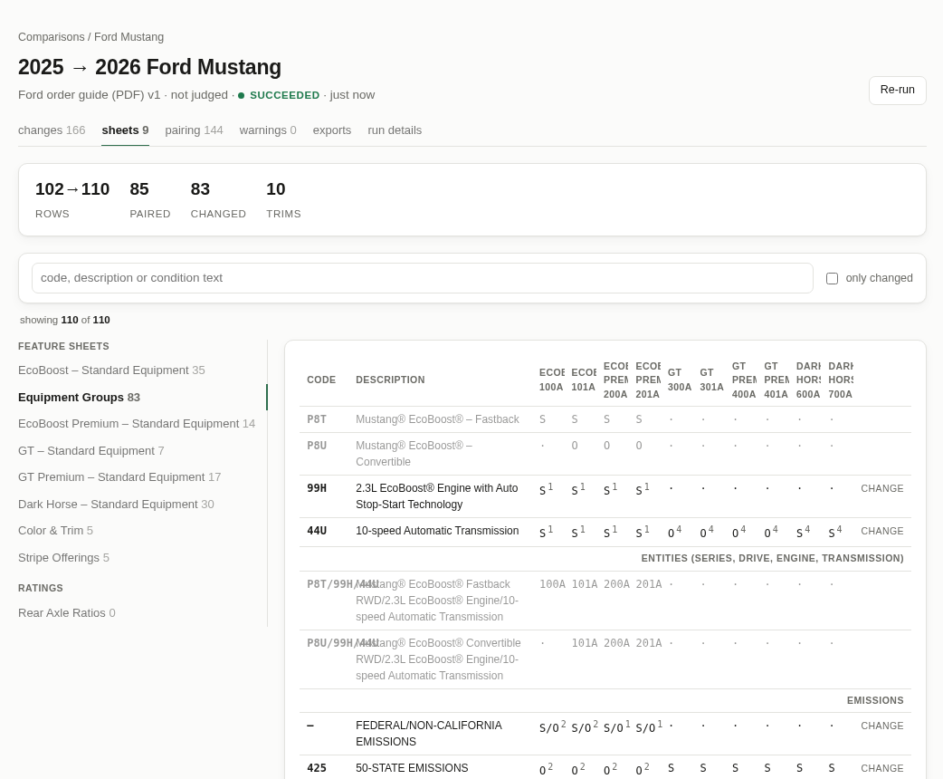
Figure 17. The Ford Equipment Groups sheet: one column per equipment group across all series.
- Notes under an option (“Note: Not available with …”) are treated like GM footnotes, so a note added or dropped shows as a condition change.
- Package contents (the bulleted items under a package) are compared item by item, so “the Bronze Appearance Package lost its spoiler” is its own line.
- Not read: the Emissions and Powertrain pages, the National Discount Packages page and Ford’s own Major Product Changes pages. The Major Product Changes pages are a useful cross-check — the app finds the same changes independently.
- Trademark marks (®, ™) are ignored when comparing, so “Co-Pilot360™” becoming “Co-Pilot360®” is not reported.

7. Administration
Administrators only
Everything in this section is only available to users with the administrator role.

7.1 Rulesets
A ruleset is the set of instructions that tells the app how to read one manufacturer’s order guides and what to ask about the changes. The app comes with two: GM order guide (xlsx) for GM Excel exports and Ford order guide (PDF) for Ford PDFs.
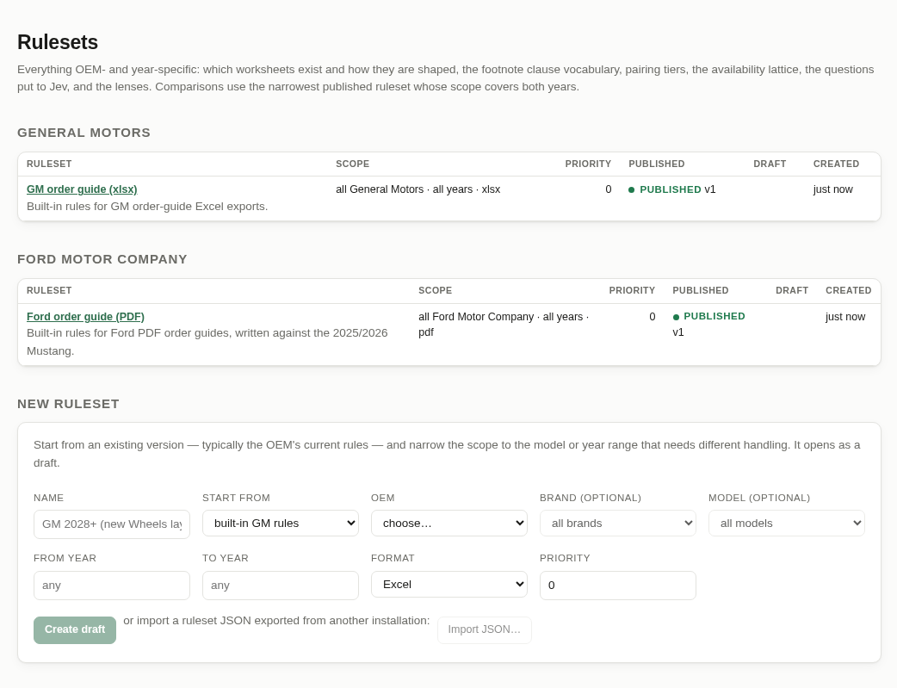
Figure 18. The Rulesets page.
Each ruleset has a scope — which manufacturer it is for, and optionally which brand or model, which model years, and which file format (Excel, PDF or any). When a comparison starts, the app picks the published ruleset whose scope fits best:
- A ruleset for a specific model beats one for a brand, which beats one for the whole manufacturer.
- Among equally specific rulesets, the higher priority wins.
- Both model years must fall inside the ruleset’s year range, and the documents must be in its format.
So if Ford changes its layout from 2028, you would not edit the existing Ford ruleset; you would create a new one scoped to “Ford, from 2028” and leave older comparisons exactly as they were.

Creating a ruleset
At the bottom of the Rulesets page, New ruleset asks for a name, what to start from (usually the manufacturer’s current ruleset), the scope and a priority. Create draft opens it in the editor. Import JSON… creates a ruleset from a file exported from another installation.
Good to know
To support a new manufacturer, first add it on the Catalog page (you choose the name its questions use, for example “Ford”), then create a ruleset for it. Until a published ruleset covers it, its documents cannot be read.

7.2 Editing a ruleset
Rulesets have versions. Published versions never change, so every past comparison can always be explained by the exact rules it used. To change the rules you work on a draft:
- Open the ruleset and click Edit (new draft). The draft starts as a copy of the latest published version.
- Make your changes on the tabs described below. The app checks them as you type and lists any problems in a red box; Save draft is disabled until they are fixed.
- Write a short Change notes entry saying what you changed and why, then click Save draft.
- Check the effect on the diff and test tabs (Section 7.3).
- Click Publish. New comparisons use the new version at once; existing ones keep the version they ran with (use Re-run to update them).
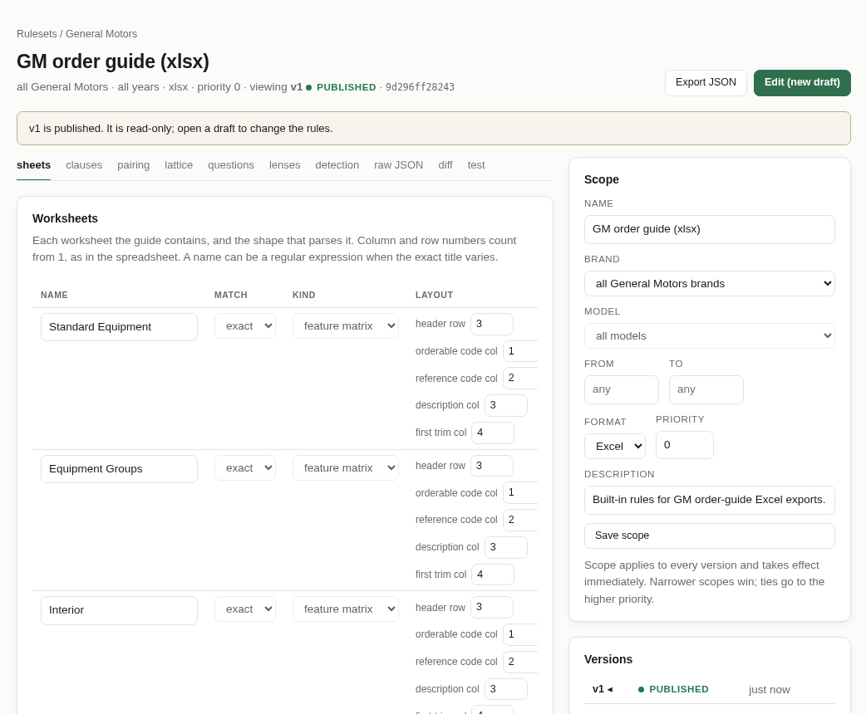
Figure 19. The ruleset editor. The Scope panel and the list of versions are on the right.
The tabs:
Tab | What it controls
sheets | Which sheets exist in an Excel guide and how each is laid out (header row, which column holds the code, the description, the first trim), and what to do with a sheet no rule names: stop, warn or skip.
clauses | How footnote and note wording is understood. Each line pairs a meaning (such as requires or not_available_with) with a text pattern; the first match wins, so drag specific patterns above general ones. Below the lists you choose which meanings affect ordering. The Try it box classifies any text you paste, using your unsaved edits (shown below).
pairing | The order in which rows are matched between years (exact match first, then by code, then by description), and which steps are switched on.
lattice | Which availability symbols mean standard, package, optional or not available — this decides whether a change reads as an upgrade, a decontent and so on.
questions | The exact wording of the questions sent to the ranking service. Placeholders such as {old_year} and {oem} are filled in for each comparison; the Preview shows the finished question for any years you choose (shown below).
lenses | The lenses offered on the changes tab and their default weights and band thresholds. The first lens is the default.
detection | The file-name patterns and section names used to recognise an upload as this manufacturer’s guide.
raw JSON | The whole version as text, for bulk edits or copying between rulesets.
diff | Every difference between this version and the published one.
test | Try this version against stored documents before publishing (Section 7.3).

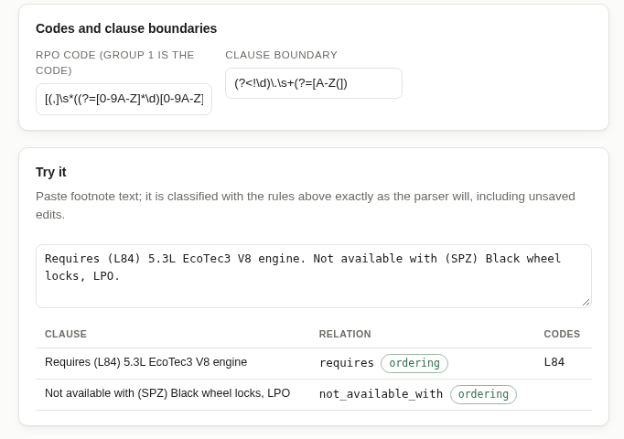
Figure 20. The “Try it” box on the clauses tab.
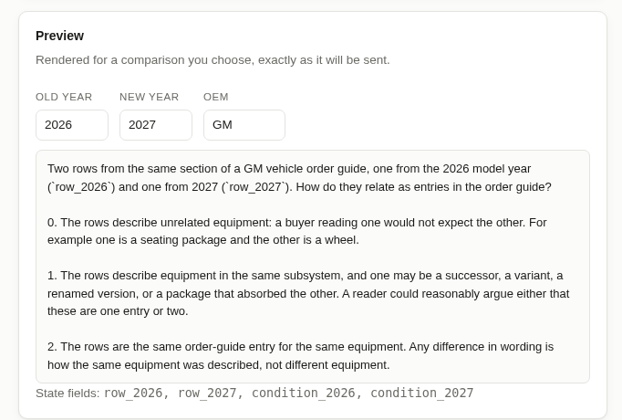
Figure 21. The questions tab’s preview, filled in for 2026 → 2027.
Good to know
Changing a question’s wording means that question is asked again — and paid for — the next time each comparison is ranked. Every other question keeps its saved answers.
Changing lenses never re-asks anything: bands are worked out from saved answers.

The Scope panel on the right edits the ruleset’s name, scope, priority and description; Save scope applies at once to every version. The Versions list lets you open any past version, and archive published versions that should no longer be offered.

7.3 Testing before you publish
The test tab reads a stored document with the draft and — if you choose a second document — compares the two, without saving anything. It then shows the results next to the published version’s:
- Footnote clauses by relation — how many clauses got each meaning. A jump in unstructured means a pattern stopped matching.
- Comparison — how many changes of each kind the two versions find. A large swing is a sign to look closer before publishing.
- Unstructured clauses — examples of wording no pattern matched, which may deserve a new pattern.
- Warnings — anything the draft could not read.
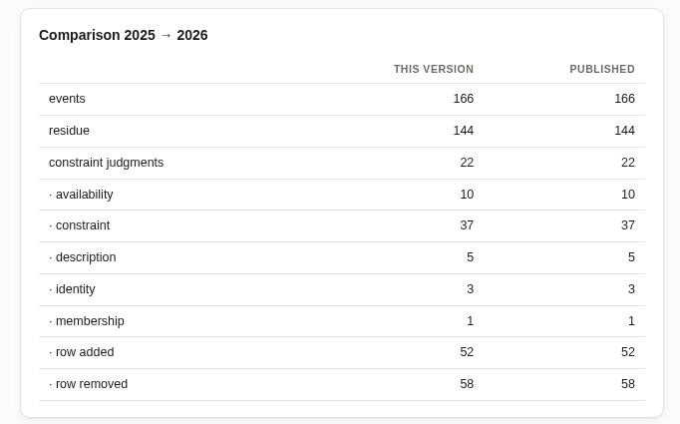
Figure 22. Test results: this draft finds exactly what the published version finds.
Save the draft before testing; the test uses the saved version.

7.4 Judgment cache
Every answer the ranking service has given is saved, keyed by the exact question wording and the exact change it was about. This is what makes re-running comparisons free.
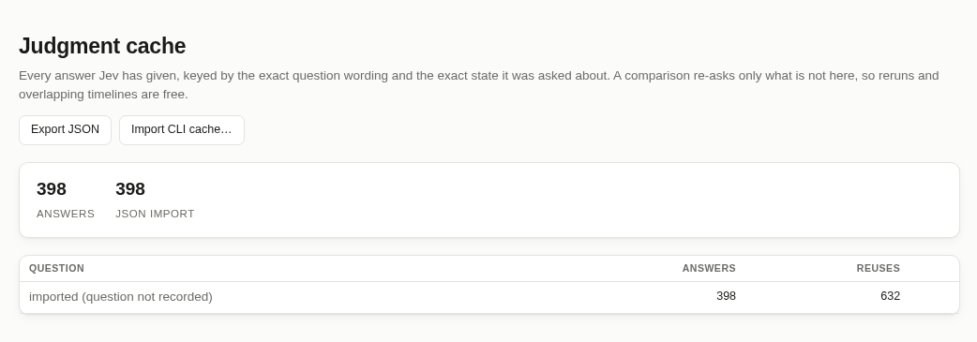
Figure 23. The Judgment cache page.
- The table shows how many answers are saved for each question and how often they have been re-used.
- Import CLI cache… loads the answers saved by the command-line version (the file .jev-cache/judgments.json), so comparisons already run from the command line cost nothing in the app.
- Export JSON downloads every saved answer.
- forget deletes every saved answer to one question. The next ranked runs will ask it again, and pay for it — only do this if the answers are known to be wrong.

7.5 Users
Lists everyone who can use the app. Change a person’s role between analyst and admin, or untick Active to stop them using it. Add a user takes a name, email address and role. You cannot demote or deactivate yourself, so there is always at least one administrator.
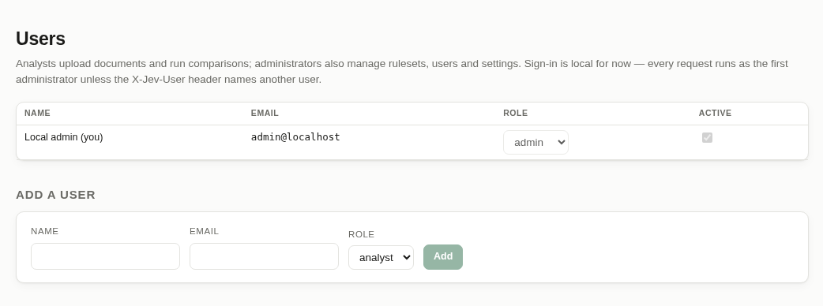
Figure 24. The Users page.
Good to know
Sign-in is currently local: the app opens as the first administrator. The roles are already enforced, so when proper sign-in is added nothing else changes.

7.6 Settings
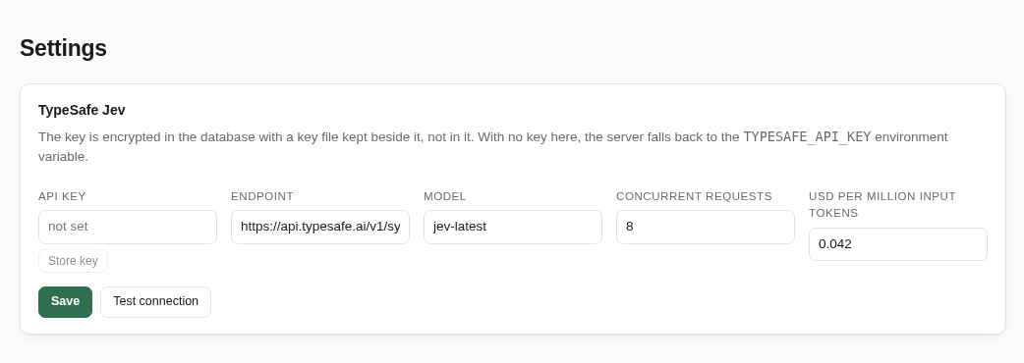
Figure 25. The Settings page.
Setting | What it does
API key | The TypeSafe key used for ranking. It is stored encrypted and never shown again — only its last four characters. Remove deletes it. If no key is stored here, the app uses the TYPESAFE_API_KEY environment variable.
Endpoint, Model | Where ranking questions are sent. Leave these alone unless TypeSafe tells you otherwise.
Concurrent requests | How many questions are sent at once during ranking.
USD per million input tokens | Used for the cost estimate after a run.
Test connection | Sends one tiny question to check the key and endpoint work before a long run.

7.7 Audit log
A read-only record of who did what and when: uploads, confirmations, comparisons, ruleset edits and publications, settings changes and user changes. API keys are never written to it.
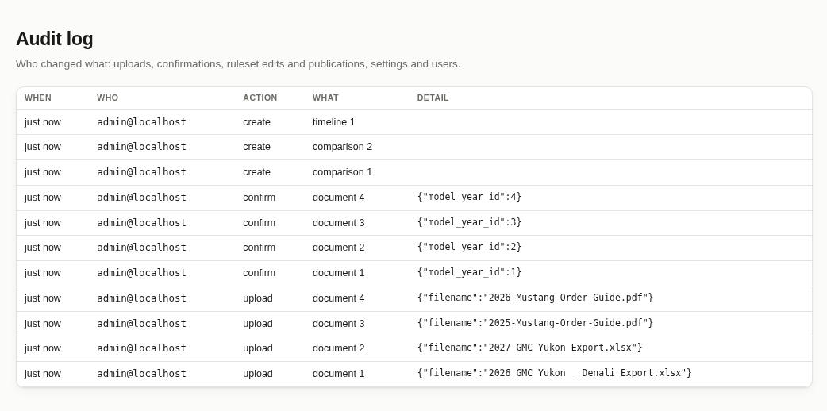
Figure 26. The Audit log.

8. A recommended routine
A suggested replacement for the paper routine. It works through the changes from most to least important, so if you are interrupted, the important work is already done.
- Upload and confirm. As soon as a new guide is published, drop it into the Document library and confirm it. Check its page shows OK.
- Run the comparison against last year (Section 4.5), with ranking on.
- Material changes. On the changes tab, click the review band button so only material is showing. Read every card.
- Review changes. Switch review back on and material off. Read each card and decide whether it matters for your team.
- Uncertain matches. Open the pairing tab and look at the needs review group. Decide whether each one is the same feature reworded, or genuinely new or retired.
- One sheet at a time (optional). For sheets your team cares most about, open the sheets tab, pick the sheet and tick only changed.
- Skim cosmetic changes (optional). Switch cosmetic on and scroll through quickly to confirm nothing important was classified as cosmetic.
- Share the results. Send colleagues a link, or build the report or marked-up workbook on the exports tab (Section 9).
Stop doing | Start doing
Printing both years’ guides | Uploading each guide once to the Document library
Decoding footnote numbers by hand | Reading the condition wording on each change card
Highlighting every changed cell | Using the colored cells in the marked-up workbook
Deciding from scratch which changes matter | Starting with material, then review
Retyping a change list for the team | Sending a link, the report or the Change Log
Keeping folders of old printouts | Opening past comparisons from the Comparisons page

9. Sharing and saving your place

9.1 Sending a link
Every page in the app has its own address, including your filters and lens settings. To show a colleague exactly what you are looking at, copy the address from the browser’s address bar and send it. For example:
…/comparisons/1/changes?kind=availability
…/comparisons/1/sheets/standard-equipment?changed=1
…/comparisons/1/changes/4f2a9c1e (one particular change card)
- Click a change card to put its own link in the address bar.
- Bookmark a page to come back to the same view later.
- The browser’s Back button takes you to the previous tab or page.
Links only work for people who can open the app. For anyone else, send a file.

9.2 Sending a file
Build a report or annotated workbook on the comparison’s exports tab (Section 6.7) and send it by email, Teams or a shared drive like any other file. The report opens in any browser, needs no app, no account and no internet connection.
Good to know
Reports and workbooks contain the order-guide content. Share them only with people who are allowed to see the order guide.

10. Troubleshooting and common questions

10.1 Messages you might see
What you see | Where | What to do
“not a supported order-guide format” | Upload | The file is not an Excel export or a PDF. Check you picked the right file.
No suggestion, or a wrong one, under Needs confirmation | Upload | The file name or layout was not recognised. Choose Something else… and type the details. If this happens for every file from one manufacturer, tell an administrator — the ruleset’s detection may need updating.
Parse status Fatal | Document page | The app did not recognise part of the file and stopped rather than risk missing changes. Check you uploaded the original, unedited download. If it still happens, send the document’s warnings to an administrator.
“no published ruleset covers …” | New comparison, confirm | No ruleset fits this manufacturer, years and format. An administrator needs to create or widen one (Section 7.1).
“fix parse problems first” | New comparison | One of the chosen documents has a Fatal parse status. Choose another document or fix the problem first.
Comparison failed, mentioning TYPESAFE_API_KEY or HTTP 401 | Comparison page | The ranking service key is missing or wrong. An administrator can check it with Test connection on the Settings page. Meanwhile, re-run with ranking unticked.
A red box saying some judgment requests failed | Comparison page | The ranking service could not be reached for some changes; those are left unranked. Click Re-run later — answers already received are kept.
Job failed: “interrupted: the server stopped mid-run” | Jobs, comparison | The app was restarted during the run. Click Re-run; nothing already paid for is lost.
“an annotated workbook needs an Excel new-year document” | Exports | Workbooks can only be built from Excel guides. Use the HTML report for PDF guides.

10.2 Questions about the results

A change I expected is missing.
First click the cosmetic band button — cosmetic changes are hidden when the page opens. Then click clear to remove any search text or filters. If it is still missing, the footnote number may have changed without its wording changing; the app deliberately ignores that.

The same option appears on several sheets. Why is there only one card?
When the same row changes the same way on several sheets, the app shows one card and lists the other sheets after a “+” (for example “Equipment Groups + Interior”). About three-quarters of GM option codes appear on more than one sheet, so this saves a lot of repeat reading.

The app says an option was retired, but I can see it on another sheet this year.
The app only matches rows within the same sheet. If an option moved to a different sheet, look for it in the moved off sheet / moved onto sheet groups on the pairing tab.

Do I have to agree with the band?
No. The band is a suggestion to help you prioritise. You make the decision. That is why every card shows the actual before-and-after symbols and conditions.

Does running a comparison again cost money?
Running the same two documents again is free and quick: every answer is re-used. Only a new pair of documents, or a changed question in the ruleset, is ranked again, and even then the cost is small.

Someone ran the same comparison and got a different answer.
Open run details on both. If the documents or the ruleset version differ, that explains it. If one was ranked and the other was not, the bands will differ.

Can I record my decisions in the app?
Not yet. Build the annotated workbook and add a notes column to its Change Log tab.

Can I compare other vehicles?
Yes — any model whose guides are in a format a ruleset covers: GM Excel exports, and Ford PDF guides laid out like the Mustang’s. Other manufacturers need an administrator to set up a ruleset first.

11. Quick reference

Compare two years
- Document library → drop both files → Confirm each.
- New comparison → model → two years → Run comparison.
- Read material, then review, then the pairing tab’s needs review group.
- Exports tab → Build report or Build workbook to share.

Bands
Band | Action
material | Read every one.
review | Read and decide.
cosmetic | Hidden by default; skim if you have time.
unjudged | Ranking was off; treat as review.

Comparison page controls at a glance
Control | What it does
changes / sheets / pairing / warnings / exports / run details | Switch between the views.
Search box | Find by code, description or condition text.
Sheet, trim, kind drop-downs | Narrow the list.
Band buttons | Show or hide material, review, cosmetic.
clear | Remove all searches and filters.
only changed (sheets tab) | Hide unchanged rows.
CHANGE (sheets tab) | Jump to that row’s change card.
ordering accuracy / content ops | Change the point of view used to rank. Default: ordering accuracy.
Re-run | Run the comparison again, re-using saved answers.
theme (menu) | Light or dark colors.

Reading a trim line
You see | It means
S → -- | Was standard, now not available.
-- → A/D | Was not available, now available dealer-installed.
O → O/-- | Still optional on one body style, no longer available on the other.
A/D → A/D CONSTRAINT ONLY | Same availability; only the conditions changed.
+ Requires … | Condition added this year.
− Requires … | Condition dropped this year.
grey line, UNCHANGED | Nothing changed for this trim.

Appendix A. The command line
The command-line tool from version 1 still works and reads the same order guides with the same rules. It is useful for automation, or on a computer without the app. From the project folder:
uv run jev-diff compare "OLD.xlsx" "NEW.xlsx" \
--old-label 2026 --new-label 2027 \
--judge -o report.html --annotate 2027-annotated.xlsx
PDF guides need a PDF ruleset, which can be exported from the app (Export JSON on the ruleset’s page) or from the tool itself:
uv run jev-diff rules export-default --ruleset ford-pdf -o ford.json
uv run jev-diff compare 2025-Mustang-Order-Guide.pdf \
2026-Mustang-Order-Guide.pdf --ruleset ford.json --oem Ford
Answers saved by the command line (in .jev-cache/judgments.json) can be loaded into the app from the Judgment cache page, so nothing is paid for twice.

